**QF 604 – Econometrics of Financial Markets**

**The Dow Jones Utility Average & Possible Smart Beta Alternatives**

**Team Members:** Jin Weiguo, Kim Chan-Jung, Johnny Quek, Wang Boyu, Woon Tian Yong

**Section 1: Introduction**

**Section 2: Data Sources & Preparation**

Our data sample includes stock and relevant fundamentals data on all stocks which have ever been members of the Dow Jones Utility Average index for the period between 1963 and 2018 (the sample period). We obtained the bulk of our data from Wharton Research Data Services (WRDS), from which the Center for Research in Security Prices (CRSP), Compustat - Capital IQ and CRSP/Compustat Merged Database (CCM) databases were utilised. We also tapped on the Bloomberg database for membership data on the Dow Jones Utility Average, though the information provided was incomplete and was supplemented by information from [this article by Global Financial Data](https://www.globalfinancialdata.com/GFD/Article/a-brief-history-of-the-dow-jones-utility-average).

**Center for Research in Security Prices (CRSP)**

The Center for Research in Security Prices (CRSP) provided us with relevant data on the monthly closing price, adjusted returns and outstanding number of stocks. We used PERMCOs and PERMNOs as unique entity and issue identifiers when navigating the CRSP database.

**Compustat - Capital IQ**

Compustat provided us with the relevant fundamentals data (e.g. Net Income, Operating Cash Flow etc) on the relevant constituent stocks of the Dow Jones Utility Average. We used GVKEY as unique entity-level identifiers when navigating the Compustat database.

**CRSP/Compustat Merged Database (CCM)**

We used the CCM Database to obtain the links between the unique PERMCO and GVKEY identifiers for the CRSP and Compustat databases respectively. This allowed us to be able to link stock price and market capitalisation data to other corresponding fundamentals (e.g. computed ROCE, ROA numbers) data at the entity level. With that said, not all required data was found to be available for our sample period.

**Computation of Fundamentals**

Using data obtained from both CRSP and Compustat, the following 10 selected fundamentals were then computed for each eligible company for each year:

|  |  |  |  |  |
| --- | --- | --- | --- | --- |
| **Description** | **Equation** | **Price Return Index** | **Total Return Index** | **Comments** |
| Market Capitalisation | Share Price x No. of Shares Outstanding | Yes | Yes |  |
| Return on Assets | Net Income/Total Assets | Yes | Yes |  |
| Return on Capital Employed | EBIT/Capital Employed | Yes | Yes | Capital Employed = Total Assets - Current Liabilities |
| Return on Invested Capital | NOPAT/Invested Capital | Yes | Yes | NOPAT = EBIT x (1-Tax Rate) |
| Gross Margin | Gross Profit/Revenue | Yes | Yes |  |
| Profit Margin | Net Income/Revenue | Yes | Yes |  |
| EBITDA Margin | EBITDA/Revenue | Yes | Yes |  |
| Operating Cash Flow Margin | Operating Cash Flow/Revenue | Yes |  |  |
| Current Ratio | Current Assets/Current Liabilities | Yes | Yes |  |
| Long Term Debt to Total Equity | Long Term Debt/Total Equity | Yes | Yes |  |

**Section 2: Smart Beta Index Construction, Methodology & Initial Findings**

We then proceeded to construct smart beta indices based on the 10 fundamentals we have selected. Our weighting method is as follows:

$$w_{i,t}=\frac{f_{i,t-1}}{\sum_{i=1}^{N≤15}{f_{i,t-1}}}, \sum_{i=1}^{N≤15}{w_{i,t}}=1$$

where $w_{i,t}$ is the weight assigned for stock $i$ for trading year $t$, based on its fundamentals data from fiscal year $t-1$, where the sum of the weights of the individual stocks for any year is 1. For every year, only stocks of companies which were officially members of the benchmark index (the Dow Jones Utility Average) were included in this weighting process. In the case of the problem of missing data encountered for certain eligible companies in certain years, said companies will be excluded from the Index for that year ($w_{i,t}=0$). For that reason, our constructed indices may have less than 15 constituent stocks for some years, but never more than 15 constituent stocks for any year (as with the benchmark index).

Our constructed price and total return smart beta indices were first constructed on June 1963 and June 1988 respectively, with rebalancing taking place every year at the end of June. The weighting approach using fundamentals data from fiscal year $t-1$ for weights for trading year $t$, coupled with our approach of performing annual rebalancing only in end-June allows for the real-world replication of our smart beta indices based on known values at the time, as full fiscal year fundamentals data are usually only released at the end of Q1 of every calendar year.

Further, we only started our smart beta total returns indices from June 1988 owing to a lack of prior price data on the relevant benchmark index (the Dow Jones Utility Average Total Return) and on Operating Cash Flow Margin fundamentals data. As can be inferred, owing to a lack of data, price return smart beta indices based on Operating Cash Flow Margin were not constructed.

Given how some of our chosen fundamentals (e.g. ROA, ROCE, ROIC etc) can take on negative values, we allowed our indices to be fully unconstrained. This means that long or short positions on eligible stocks were permitted with no set limits. We also established an “absorbing state” for the prices of the smart beta indices to be at 0 (indicating a total loss of initial capital), with any of our indices reaching or exceeding that floor deemed to be failed ones and as such excluded from further analysis. Our constructed smart beta indices

**Initial Findings**

The superior smart beta index become clear as day after the computed smart beta index prices were plotted over time. For both price return and total return smart beta portfolios, the portfolios with ROIC-based weightings achieved far superior returns over our other constructed indices.

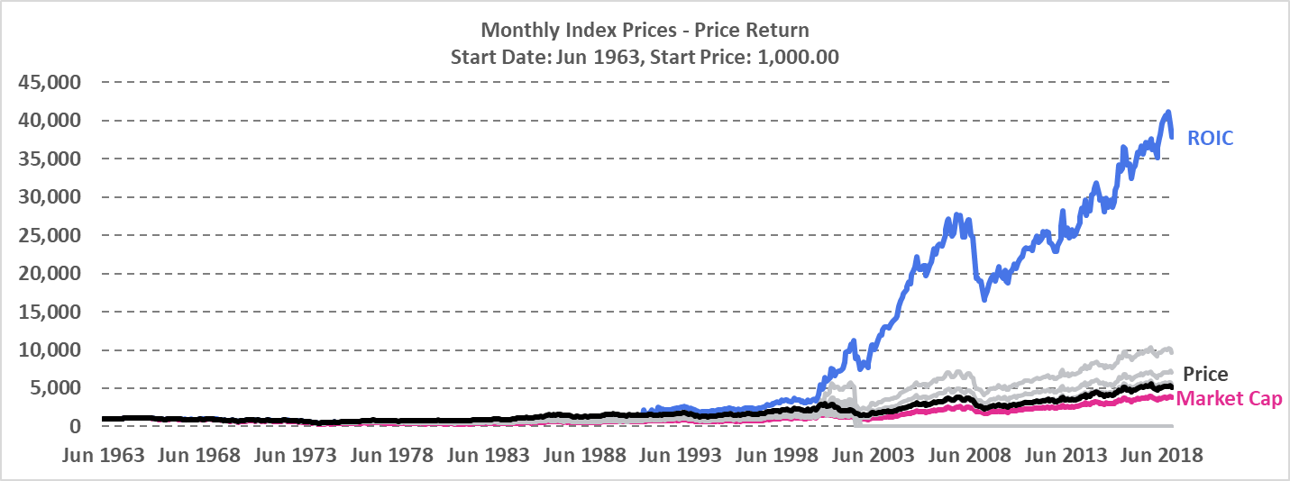

To put things into perspective, the value of $1 invested in our constructed ROIC-based total return smart beta portfolio at Jun 1988 would be worth $197.10 at the end of 2018 (excluding transaction costs), while an identical $1 invested in the benchmark total return index over the same time period would be worth “only” $15.77.

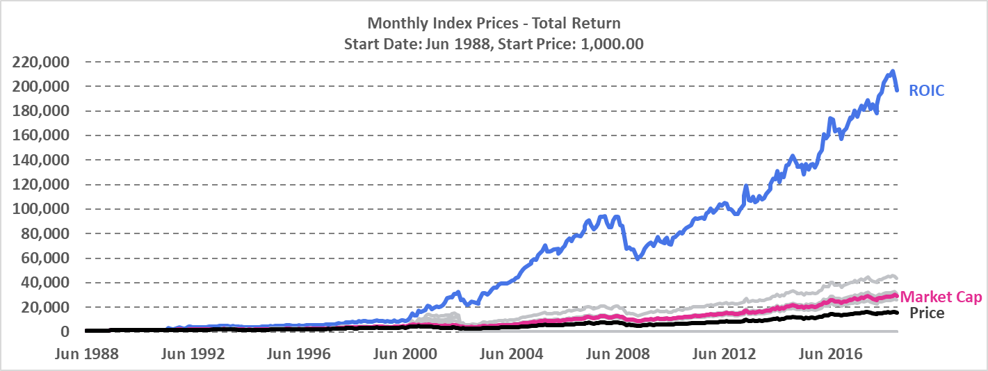

For our constructed price return indices, coming in as faraway second and third place were the ROCE and Current Ratio-based smart beta indices. Amongst the portfolios which survived the sample period, indices weighed based on price and market capitalisation performed the worst.

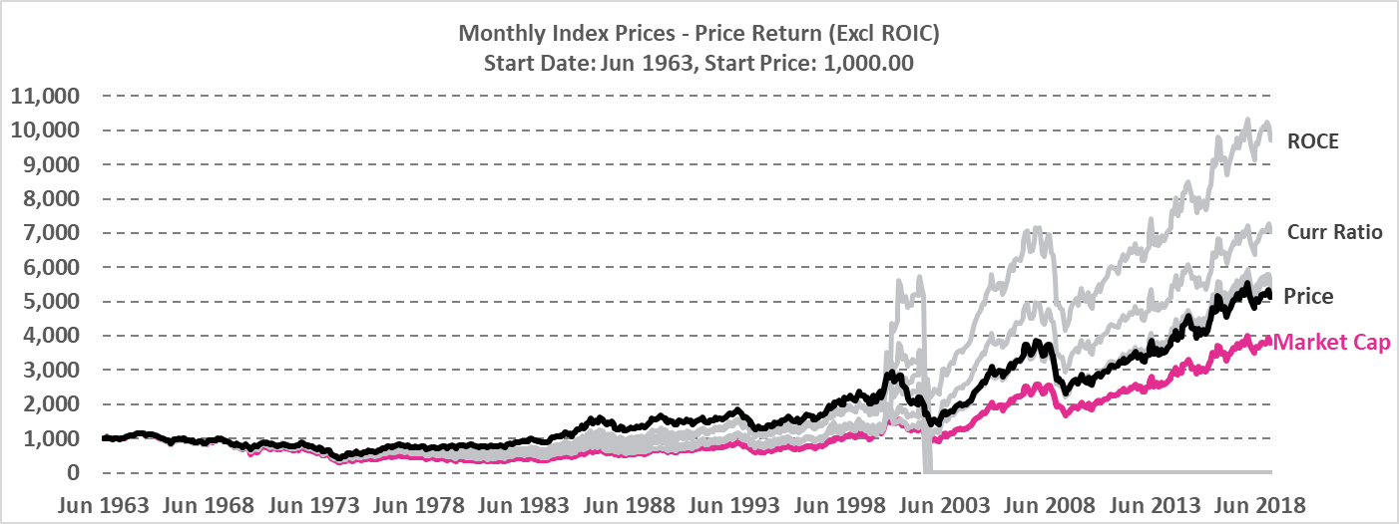

As with the case of the constructed price return indices, the second-best performing portfolio was the one weighted based on ROCE, with the Operating Cash Flow Margin-based index coming in third. The price-weighted index was once again amongst the worst performing but surviving ones.

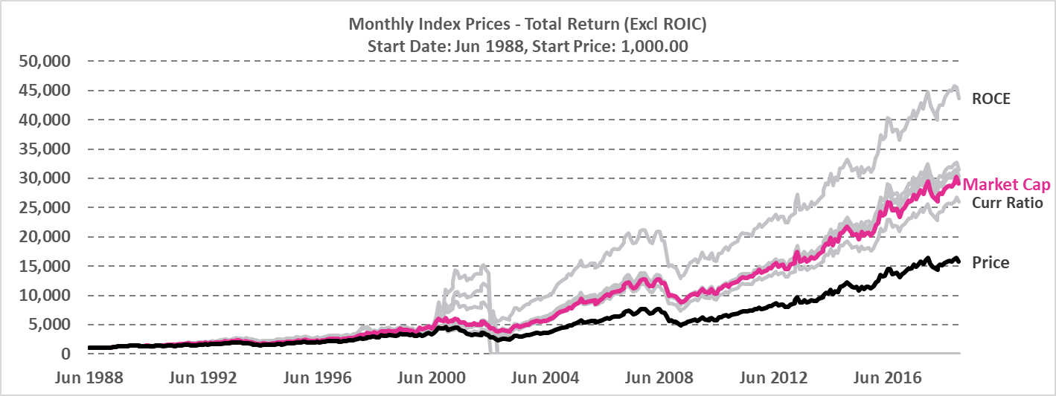

We also observed a few constructed portfolios which have failed over our sample period, namely the ones with weight allocations based on ROA, Profit Margin and LTDE Ratio.

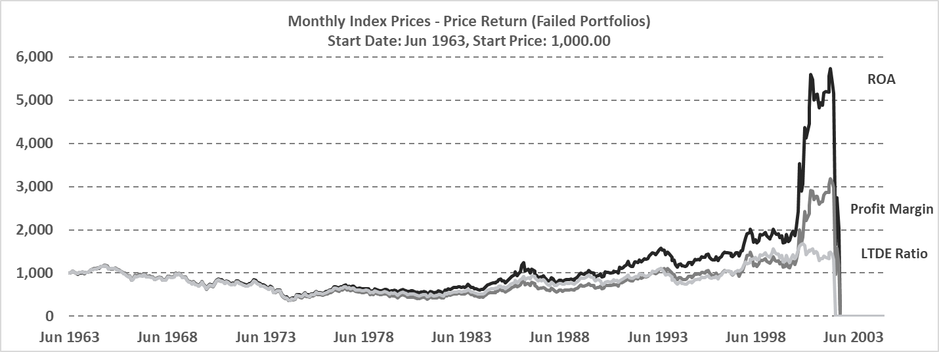

All of the failure cases were the result of a few extensive (and sometimes successive) losses incurred from prescribed unprofitable and extremely large short positions taken on the same few constituent stocks, the result of one of the drawbacks that come with allowing fully unconstrained portfolios. The failures were also observed to all have occurred in mid-to-late 2002.

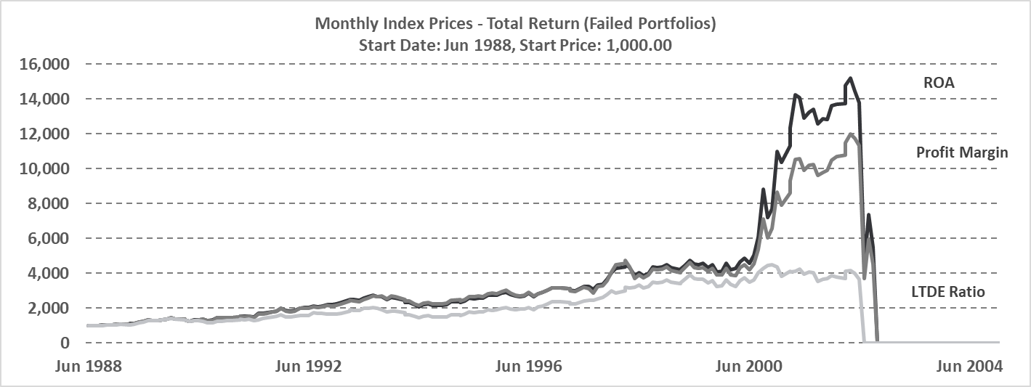

Failed constructed portfolios were excluded from further analysis.

**Section 3: Index Performance Appraisal**

**Section 4: Autocorrelation of Fundamentals**

**Section 5: Further Regression Studies**

**Section 6: Conclusion**